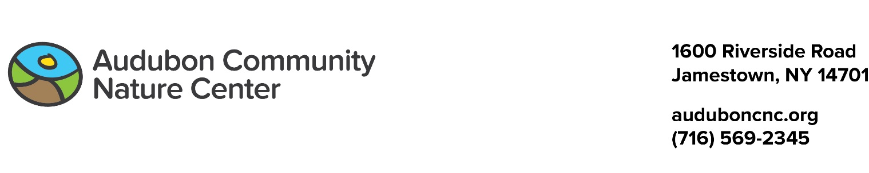

2018 What-to-Bring to Camp List

Thank you for registering your child for an Audubon Day Camp program.

We will do our best to make sure your child has a wonderful time. Here is what we need from you:

Every day:

Please dress your children in play clothes! They will likely get dirty. Also, for safety reasons, ACNC requires that children wear closed-toed shoes and socks — no sandals, crocs, or clogs.

Send your child with the following:

- A lunch that does not need refrigeration. (for camps that go until 3:00 p.m. only)
- A water bottle, or two. (Completely thawed ones, please.)
- A snack or two. (Even for the half-day camps.)
- A hat is great for keeping sun out of eyes and bugs out of hair.
- Some insect repellent: we recommend lotion, pump-top, or wipes. Please do NOT send aerosol sprays. To be effective against mosquitoes and ticks the health department recommends a 20% concentration of DEET or higher OR (for mosquitoes) ones containing oil of lemon eucalyptus.
- If you want to send sunscreen, please send lotion, pump spray, or wipes, not aerosols.

First day:

Please send a complete change of clothing, including underwear, socks, and shoes. Make sure everything is labeled with your child's name. Put everything in a plastic bag, also labeled with your child's name. ACNC will use this if your child gets wet or muddy (it happens often). The plastic bag helps keep backpacks from also getting wet and muddy as the wet things go back in it. If we use the change of clothes, send another the next day.

If your child will need medications or an inhaler during camp, make sure it is labeled with your child's name and that you notify the Camp Director when you sign in.

