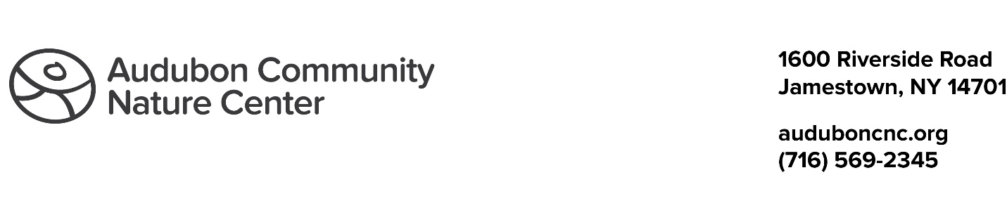

Blue Heron Legacy Society Acknowledgement Form

I/We have chosen to include a gift to Audubon Community Nature Center in my estate plans.
I/We have done so in the following way (check one):
Included ACNC as a beneficiary in my/our will
Included ACNC as a beneficiary of my/our IRA Account or Retirement Plan
Included ACNC as a beneficiary of my/our designated fund
By submitting this document, I/we commit to leaving a legacy that continues to create real and healthy connections to nature for children of all ages within the local community. I/We also commit to becoming a part of Audubon’s Blue Heron Legacy Society.
For publication and recognition purposes, I/we provide the following directive (check one):
I /We give ACNC permission to include my/our name in printed publications and online information related to the Blue Heron Legacy Society.
I/We prefer to remain anonymous.
Name (1) (First and Last) | Name (2) (First and Last)
Address
City, State, Zip Code
Phone Number | Email Address
Printed Name (1) | Printed Name (2)
Signature (1) and Date | Signature (2) and Date

Received by ACNC representative on .
Signature _________________________

Audubon Community Nature Center is a registered 501c3.
Legal Name: Jamestown Audubon Society Inc., DBA Audubon Community Nature Center
Tax ID: 16-6031149

